_{rft{.M} ^{q\} ts c-:
ffi
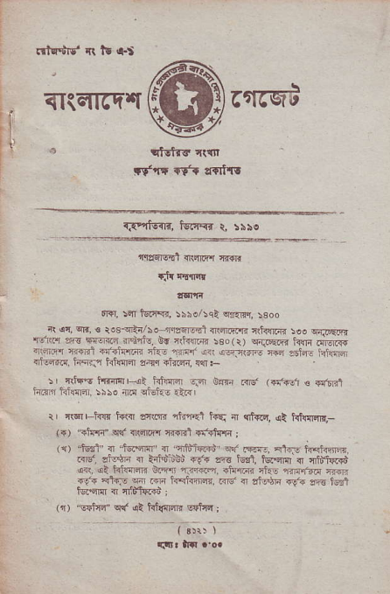
qIicfirc'|t _{6fr6qi}
,1
rt' rr .Tt ,r{rtT!
r.e{ifir, tsr{.{r r, !}re
^{trr?fqEd} <nEr.{-q 4rF1t
rJr clrrlllr
o.r, _{r6n nirqr, iiso/:cl} ^{qqm,} !300
i( ar, on, € ro3{i/he-n€6lt-1{'4rir.tlr _{nrh{nc soo} q{JE|r" 16r{'l re ETo{i m41re _{dr lrh{F{ ieo(r)} ^{qniqR} i<ii ^{riiiiR qr;i@} _{{i€l .i.riflrjn} ^{qtu-} _{niqr! {rt} ^{(q5nd :r€} 261nj i!l@ {N*{dd, hq- htudl ziir alnc.1w.-
:r {ltrt t.8ffir{i tifl@ nF im Frt' ^{(rn{d} € €,611 hF hf!{lEr !5N nd ctuhc.t{r
i' fl6r hrc t+t{ _{lrtos} ^{'rirnel} i+q _{n} ^{q]tsiq,} et hnl{Fr!,_ ^{'.tu'n"} s{ {(ai{{ cn'F1 si<d{F ,
^{'i"rl-} _{a} ^{.*fl} {'mt"@ ^{\,*,.-.^} lT4t*,". .{t. aiilt,. ir'.i rBi ^{ra.} E 5$, tqqrl a '6u>ffi dll. dl hnE6rr oim ..:r.li@. ilq"riqi _{rkE} ^{'fr{In} en _{rF} q'q ^{Fr.rI.-@,@} ra_riiF {r1+ftr}t
tci.qm n rfdffi :
_{"!$lqd} ^{q{ qt} hilqrqR sqtar j
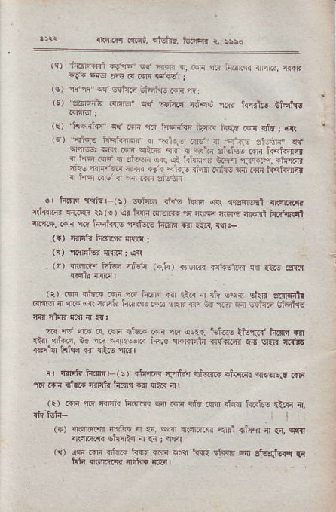
{i!rm .aot, eMiE. iEirEr r, r!!o
i.er*rn _{${'rs,q"r} ^{qinF {r,.ira} fti i[dE ii rrlEl, r{+E 4!r 4E afg R ^{.ffi .r.?sl} ;
4 _{m"} ^{q(} @ft.a inF]llG .qr ft i
"3irFrtu _{.sint6r"} ^{qcr E$iilc} _{c$q.n} ^{'roi{} MIg €t|qt{v
^{Flqr4h4} k{dl Fq- .fln _{{i.} ^{j} 4R
_{"<1qe} hFfnrfl' a -ln- ..&.' { "Fi-. .ir+F, ^{sn, q1@!} {r"r _{Fir} q:.4r ^{qlfl} { ^{q{ftn} aMt- .ilr h,rfr{rq { Fw _{.{ti { dE.tlr} ^{qii} sl t{fuiraR 6.-flr ^{firrr"r. rtuffir} ciae maftzc ni{,r ila airic ci-Rr _{iqi:ro} ^{q;} c€ H-d{r {f f{qr 6d { ^{qa} m zindrn
o, irdr rdE,-(s) !sii.- _{ri<. h1rr arr} qlssllqt ^{:npnR} l r(t{qG? FiiqF _{ri} ^{(o) s{ hn .{roi{s} _{"l?} EGTq n(a'g r{'{lli h#'Il l crmf, R'r n.E inliirF 8,to{r _{h.{r!I} qa ^{qtr{,} {ciF
^{(t) 4ilfi tsr{ri'I{ cnr.!} ;
(q) ^{'ifi16F{} rrlrEl ; {1
^{(t)} {rT?r iituq cri5" (di) {16r'{r o{ie.1iri {"r Rb a!i.l
^{(r)} @ {icq i4]" ff h.n $ar .la { di @eir stnr airFnr rm { llrr{ ^{qn} rmh h.fta.T6 ri.Ii m id 11r,r 6ri lFtfte Giqirc
_{oR} -r !fr ? .d _{4tR} ^{'m ,:" .v.q} tn ^{t} _{"=i} ^{garn} F
t'{ 4'-rF _{9. ? 4iF r} ^{-.i} _{FrS cl.r-n]n fnrlrpi} ^{q-4 q{r} rr{xt r"'Irrl IFr{d $ir {t.6 inil
3r Torttu h4Er-(5) rlcfi{ fJrftrr r]fqer$ rtfi6{ crclrq tnr{ !1{.{n {nrrr {4nh kG]'t 1r1 ltR ilr
(r) riF 1r{ 4irrii iii;m fl.r14 fs rlra rtfl ffi! {t!i 4
^{q\nnim} s1{qR4 4r {{ ; s4r{
i{r dn ffi drdrd ^{l{s} _{@i} ^{!q} ha !tu'fr ^{-ir sfsqfq'{} Fl
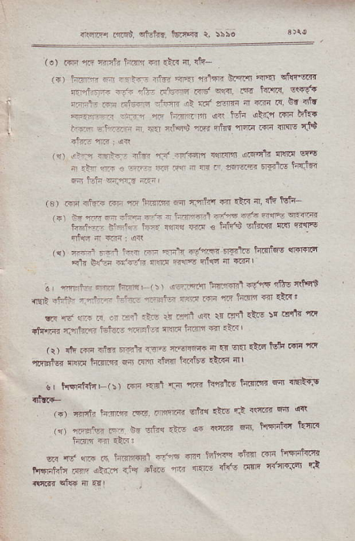
_{{lfi.q rnrri} ^{qfttrr.} torffi r, riro
^{(.)} @ n Taifr tim a rilr rJ. sh
⁽⁺⁾ _{tri:r} ⁻ _{i-r-} ^{r€F} _{ffi} 'r.!m eitzr {'{' qinEan _{Til,flm} .-:n ^{rrn} nfre rld *Rr. rtiE t{rRll. w9t mi.4i .r _{4i..Fi} ^{rff} ri nt' .snF a ..Ti F dr 4tt r Frr. m or t3ln ah_.r iTd &k{
f'F' -nr:r { flT *ia$ _{nF{ nhs} ^{ll@} _{idr {ff6} 'd9
ra) !rr-n @s- i.!.r rn.T6Er{ {4nm {rqrfi {$tc w's r.:r'r ? ^{,-} - _{rr {} ^{q} _{- 4rq4} ^{q€rii} ht-isr _{s i-h} s;r;,F3.L,
(c) r _{.4- =-, 4} ^{r_-*} _{a} rnlz ₆ tli _{n.} '+ *- _{r"\ i!rn.r'q} -t{ ^{ffi "f6frftftsr.ffi} trr+"-r .nH- irz irR tu € iilt'S cii@R liq B{{
1r) err rr-l F:.T ₋₁ ern+r -i5" ea.tre _{iq{rfr6} qr€Rndl F'li ffi: _{{f,.-;n} :lm ^{;ffi} rriqa { ffil
^{(r)} rh @ _{nf{r t} ^{'.1r} {3E -.dr!rr+ * rq sEI {ird tfi _{Fi} 'rr ft'nlt!? 4M h|rn s dar m ihn ilrrft€ _{*rr{} nIl
0 | Mrt{E(5) _{r{F} 'IFl '1:dI 'm ft'Ettg tda]llE w dc'tqs
^{(.)} FFlr inlm rf5. _{rnqrnr} ^{qilia} _{dis} ri _{r<ffi} qnt ''{! (r) ^{'r'rib..} r _{oi of}l ?to} ds _{.qna{} fl Fifiif4n brr! hirr R I!F:
_{cir} ^{'It,} wr F lnrffi.i {trE _{n tst{'fl Tfrfl} di t!'nii{inr ^{r-*r.i+" *"} _{"#-} ^{r*} _{"'* "rtr} anc rlts dRE c{'ff'6r r't {!ffi dG fl.{r
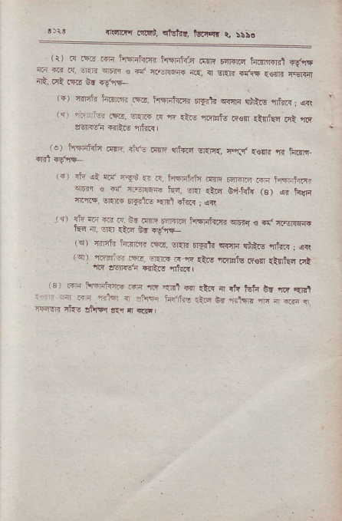
linwrq _{otq"r,} ^{qigllq tFmr} d 5sro
^{(r)} r{ FFo.rR t{hd{.{r hFlrt-{.r.6n]E r<m.q h.{rlr{Rl {!t,iE
ft crt .EE d. ct.r
^{(")} cirnft fnrnm Fa, nflnrt{rr _{Frajln} qrqi qhlts ,iftr; q{ lq) rtlflr n6, sr1F ir n .:iF n| lFtu &€ll <tntuc Ei ia ltll{ei se.q anr.rl
_{- .} ^{+Gft?} .w ^{trr.} _{t:Ep} ^{(-i'} sr,{. E-ly .offi B rirr'.
^{(r)} dr al c|a'-.q$.n d. tsffiFii,{ .nrlq dFl,r .q- hft,tr<cfr ^{qr} r ^{+f {.-o!Fi} _{kd.} ^{qtr.lFl} titd! (s) ^{q.} hfi n.@ 6r.F rdr.o €F1 $t{? ; qr\
r, ^{Fr- --} n r _{r:FF} ^{iFi?E} @!I. d,.sre{, rtdr {. .r.r .r_@ 66 +g!r
^{(q) 'rnii} h.iror. .rir. sr.q _{,rFt} ^{q{jli qii!.E} {fur: aR
rlY a6Rs". €rt(E iEr<l
^{(a)} ffi :\f|ii<eF tm _{rir} ^{,{.1} d {t." { rn tuft 6! _{G} ,rEr ' ? _{Fr} ^{-{} _{r} ^{.bi} l'+{!,nd6d=.5.r{'F! I+a.rr nt{.' ,t1 +l r{q rr E ii
rsnrl|t od, itut{r. ltrrrar i tisa
€E
't"
^{F}E
5
E..
FF F ;EEts
_{E5} q:FIf :EX _{"e Etl[.e} FEe_{::6} E;!FFE ,EEE; ^{EEE} EFFi;EFeF
eFc eFF*ii nT;: oe #AF
C
t
E
F!r
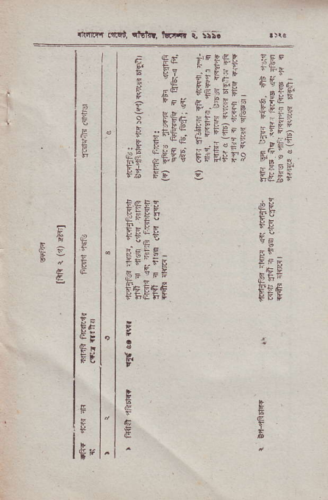
rtE.-
^{'-} r-'g
teFet
ta
€
sE
g
$
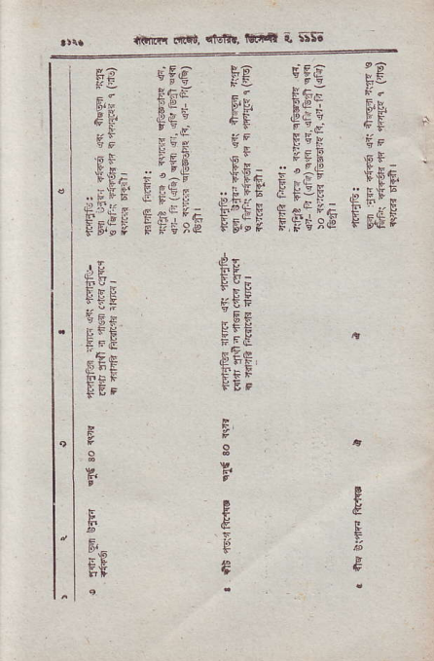
ftnfi _{.int,} qtfi!, rlk'ldr a 5i56
^{gE} :eg Fg :cg
FF Eg i F,F $E; e€, ':iq eE' 'lEE
s,€F
elig tFi" Efee rFile F _{LJAA} T
,E
FEE
gEE E F,F
FEt E
F
FI
.pE
,E ftE, FEF
G
E
€
E
E
^{(rr.Fl} arlti, tEln, llElif d *to
_{BFE ?p} ^{gFE} .EE.,E EEq F: EEd ^{$;E #:E} Ets _{#iE} qE; EF,E sl s;,Et ;k; ^{FF;} _{s* FF::} i',E
e
'E
^{EE}g
F F€:F ₋ ^{gEE} F eg:g ,f'F; F FeEsc F;iF teif Ft;ie F
I
d,E
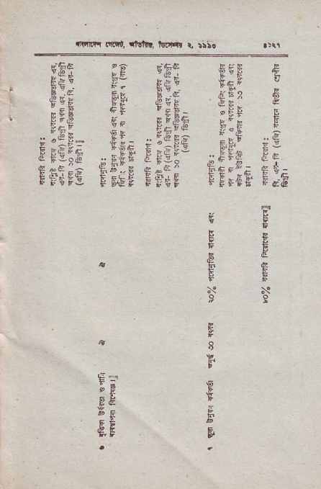
eE
Ee ,EE
E
F
t
8 I
E
^{E.}F ^{F}6
,E
F
^{Fe}FE
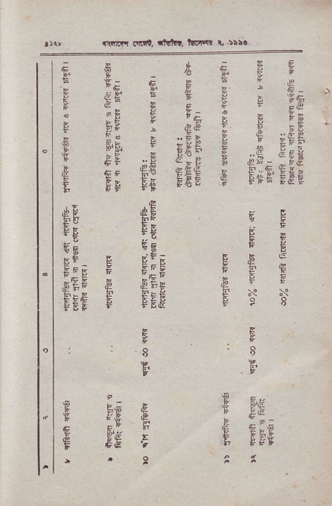
ftirrrq dm, tMr!, bEt{r d :rr.
€ ^{,s} _{E} gF _{is} e ^{E} F;€a ;s {lst ^{E E}rr .E Ef$ E ,F E_{EE E; ETE E FoB EF}
^{EF}fE
^{€e}'-e
E"; E ,FEF .P FsE F _{FEF} F
^{F;&} E
FIE
EFE
F; E F E.E
E₈
E
E
.[' ,EE tt i":
F f E.E AI
irFmq _{mqi,} ^{qt6i{!,} lwqr d :iso ; _{F} ^{-Ef} i.E,F ^{C} " 6s t-6E E
_{F} F ^{qe} E+rl _{b} ^{-E} E
F
E
€
qE'
f E ;Fl €eT € _{E eE-5EE} gHE: F'
_{fr} FtFEs.E ^{,EsF} E
.EF
E FF
F
6
E^{c}
E
E
F9
.F
F
F
E
s 8
F"
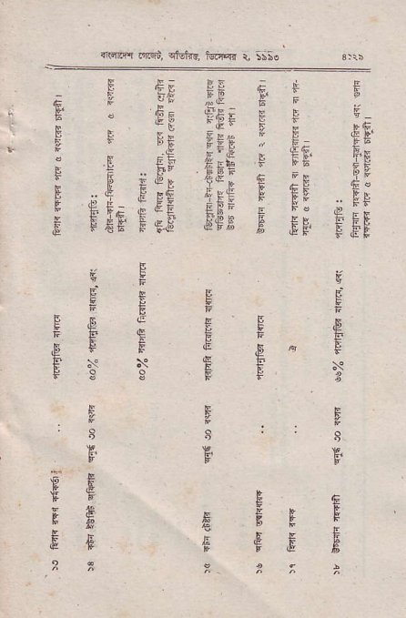
E ^{SB}F
E
.&F bE
P
N
F^{I}F
E A
E
^{:i}q
e
EE
.,u ! xB
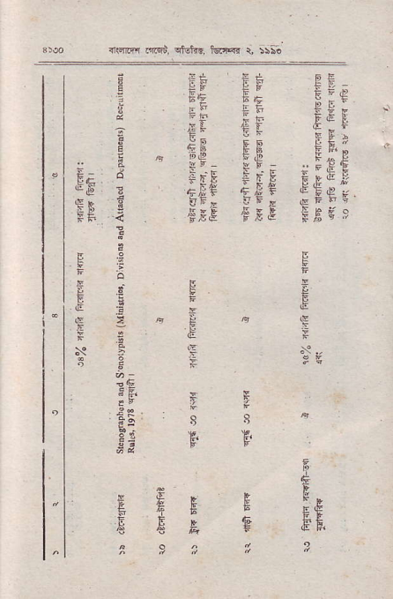
Eli
;F T,B _{;F€} ,;FE 4;Ii FEE
EIE
_{E€} }
:JFLEE E,FEF ^{EF,P} c _{EB4} T
E
E
t,
⁸F.
a 8
F
^{s.E} €,BA F
{ffir! m€i, cMrd, t€d4r Q,
^{r-!EE} EE FE lE f. _{EltE {e :E} ^{pF} F _{EEEr _ ie} ^{Fe} C _{FP*i} ^{gH} _{i} eFu.FF
:ii: rig E ;f€ fF i Esi€:d Eff E Erg rf- ;
E
4E
UE fE
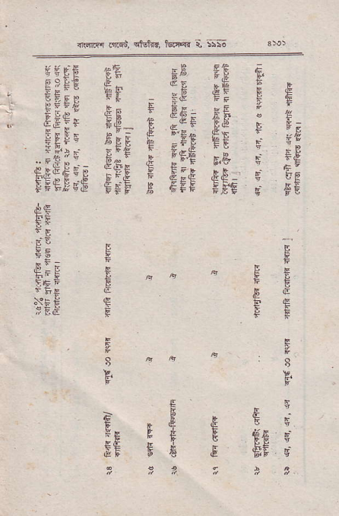
. d€
hF E }IF E
F
^{,E}F
E
8
F'
FB
E
'E
5'E FF
E I
F'
FE F E
E
lE
6E f _{eE} e
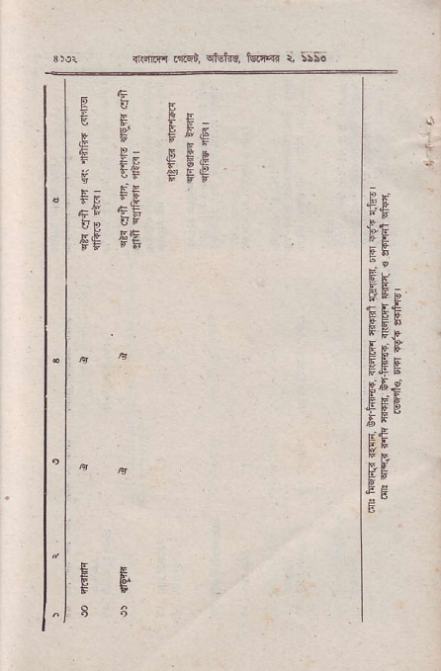
flirii{ _{r1Fi.} ^{qMn!,} foal{r t 5;56
EUE
^{C} E. E E:
.E ^{F Ft€} E E; e€e _{g} ^{Es} ;'F5
_{Fs} Ff
_{irp} sts
sg fE
EF
_{"E} E'
^{tt1: l+} E:
gb
:e
EE E
F b-g
EE.?
€Es Fg
B

